Status of PDS in Karnataka in the year 2014

The Government of Karnataka has enacted the Karnataka Essential Commodities (Public Distribution System) Control Order, 1992 to issue authorisation to Karnataka Food and Civil Supplies Corporation, Cooperative Societies, Registered Associations and individuals to run fair price depots and to regulate the functioning of these fair price depots. These fair price depots which form the core of the Public Distribution System are entrusted with the responsibility of distributing food grains to the ration cardholders attached to the respective fair price depots. It is the endeavour of the Government of Karnataka to locate these fair price depots keeping in view the convenience and interests of the ration cardholders.
The Targeted Public Distribution System has been implemented in the state of karnataka from 01-06-1997 on the direction of the Government of India. The main objective of this system is to ensure food security by ensuring minimum supply of food grains to the population below poverty line. For this purpose, households belonging to vulnerable sections of the society and living below poverty line in the rural areas and in urban areas have been identified. These families are being supplied food grains at subsidized prices.
According to the statistics provided by the Food, Civil Supplies, Consumer Affairs dept, Govt. of Karnataka in the year 2013,the govt is provided cheaper food grains at a annual cost of Rs. 7,000 crores through a network of 21,024 ration shops.
According to Dr. Balasubramaniam’s report on Public Distribution system in Karnataka in the year 2011, states that the authorities were unaware of even the exact number of ration cards in the state. While 150.67 lakh cards are officially recognized by the Government, the study revealed that 159.23 lakh cards were in circulation. The Government, however, allots grain for only 108.07 lakh cards. The total number of households in Karnataka is 120 lakh.
The report says that two big sources of loss are “overallotment loss” and “transport cost loss”. The report says that losses that occur due to the Government not knowing how many families are currently active accounts for about 38 per cent (Rs. 54.4 crore) of total losses every month. Distribution or leakages losses account for 39 per cent (Rs. 56.6 crore), which occurs during wholesale transport. The rest is attributed to “active suspect loss”, which occurs due to families suspected to be ineligible drawing rations, transport cost losses and stolen subsidy loss. The total loss is Rs. 144.8 crore every month.
The inventory management, once food grains leave the Food Corporation of India godowns, is manual, leaving huge room for manipulation. The study has revealed that the total leakage in the system at Rs1,737,6 crore annually.
Anna Bhagya Scheme in the year 2013
In the year 2013, the Karnataka Government launched its ambitious programme of “Anna Bhagya” scheme to provide food grains at cheaper price at a cost of Rs. 7,000 crores in Karnataka. The Government is expected to supply 30kg of rice per month for a family of three and above at a cost of Rs 30. The state requires 2,84,000 metric tonnes of rice every month, while it is able to procure only 1,77,000 metric tonnes. The balance quantity is being procured from Chhattisgarh.

Status of PDS in the year 2014
In the year 2014, the State Government ordered the verification of existing ration card holders to weed out duplicate and illegal card holders in the state. It set out the verification processes for which each member of the card holding family needs to send an SMS to an given number and also submission of EPIC cards, Voter Id cards, Aadhar cards and other documents. If the card holder failed to do so, their cards will be disqualified by the department.
The flaws in the verification process led to disqualification of large number of legitimate card holders of the BPL category. Shri. Dinesh Gundu Roa, Hon’ble Minister, Food, Civil Supplies and Consumer Affairs, Government of Karnataka, addressing the delegates of State Level Public Consultation in PDS on 2nd November 14, organised Right to Food Campaign-Karnataka, said that the verification process of ration card holder has led to disqualification of 5.5 lakh ration card holders in the state. The Hon’ble Minister said that AAY covered was converted into BPL cards to curb the misuse of AAY cards.
slideimage:
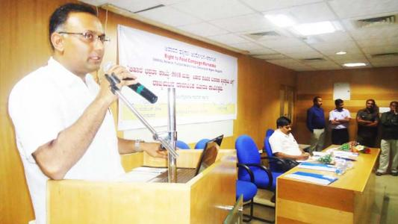

The Hon’ble Minister admitted that the department dependency on the voter identity databases of Election Commission has resulted in delay of verification process and caused hardship for the card holders. The technical issue will be sorted out soon and the department will be verify the card and issue new cards to the eligible card holders as early as possible.
The Hon’ble Minister announced that the department has decided to start new shops which will directly controlled by the department. The department will also build its own godowns at the cost of Rs. 11 lakhs in collaboration with the Panchayati Raj and Urban Development Departments.
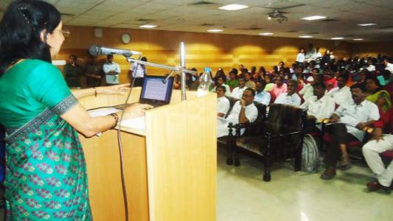
Smt. Kathyayini Chamaraj presented the "Draft Rules for the National Food Security Act 2013" on behalf of the "Right To Food Campaign Karnataka". The presentation highlighted the convergence of all schemes & resources, establishment of Compliant Redressal System and Universalisation of PDS system in Karnataka. Smt. Neetu Sharma presented the draft rules which was already submitted to the State Government.
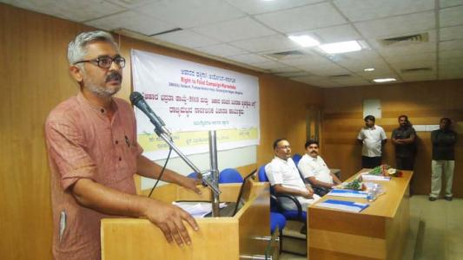
Shri. Abay, one of the organisers of Right to Food Campiagn - Karnataka presented a critical analysis on the functioning of the Public Distribution System in the State and appealed the Hon'ble Minister to streamline the functioning of the department.
Shri. Y. Mariswamy, State Organisor, Samijka Parivarthana Janandolona, Bengaluru Smt. Shardha and Smt. Swarnalatha, organisors, Right To Food Campiagn- Karnataka, participated in the Consultation.

Grievances Redressal Meeting (Adalat) on PDS held on 15 November 2014 at Nagwara Ward
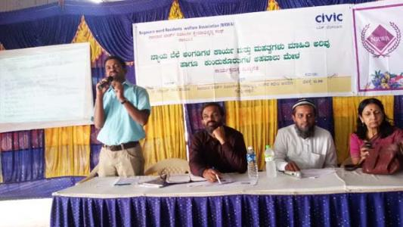
More than 200 people participated at the Grievance Redressal Meeting (Adalat) on PDS on 15 November 2014 at Nagwara ward in Bengaluru. The meeting was jointly organised by Nagwara Residents Welfare Association and CIVIC, Bengaluru
Mr. Chandre Gowda, Food Inspector, Nagwara Ward, expressed happiness and appreciated the organisers for organizing the Adalat. He admitted the numerous issues faced by the people due to department’s action on verification of beneficiaries of the PDS system in Karnataka. He shared about the department’s order on sanctioning AAY rations and stoppage of kerosene in case the beneficiaries possess gas cylinders for cooking purposes in their homes. Mr. Chandre Gowda shared that he is awaiting the verification report from the BBMP for finalizing the beneficiaries list of the department in Nagawara.
Smt. Kathyayini Chamaraj, Executive Trustee, CIVIC, said that the department is duty bound to conduct Adalat every week to address the various issues of ration cards by the people in the ward. She quoted the statement of Shri. Dinesh Gundu Roa, Hon’ble Minister, Food, Civil Supplies and Consumer Affairs, Government of Karnataka on verifying the card holder as not compulsory. She expressed apprehension that the department may not complete the verification process in the near future. She appealed to Food Inspector to ensure that the Adalats are organised once in a week or fortnight and address the issues of the people
Shri. Veeresh, Project Co-ordinator , CIVIC, presented the PowerPoint presentation on the PDS system and shared the contact phone nos of the important officials for faster reddressal of grievances. He shared about the “Public Hearing on PDS and Framing of State Rules for the National Securities Act 2013’ on 2 & 3 November 2014, organised by Right to Food Campaign in Karnataka.
Mr. Yunus Mohammed Sharif, General Secretary, Nagwara Residents Welfare Association, shared about the issues faced by the people related to ration cards and hoped that the Grievance Redressal Meeting(Adalat) will be help in solving the people at the earliest.
The participants, mostly women, shared the different types of issues faced by them in accessing the ration supplies from the ration shops and hardship experienced due to the verification process undertaken by the department.
The participants unanimously agreed to submit their grievance letters attested with copies of their ration cards and submit the organisers for submission with the department.
Mr. Chandre Gowda , Food Inspector, expressed confidence that the issues will be solved at the earliest with the support of the Nagwara Residents Welfare Association
Shri. Venkatesh, Shri. Madhu Sudhan and Shri. Ramanji, Project Co-ordinators, CIVIC and volunteers of the Nagwara Residents Welfare Association also participated in the Meeting.

