Govt. takes baby steps towards planned development of city
Sikkim Manipal University - Ranked No.1 in Distance Education. EduNxt Online Learning Platform! Smude.edu.in/Admissions_Open
Ads by Google
Krishnaprasad
Share · Comment · print · T+
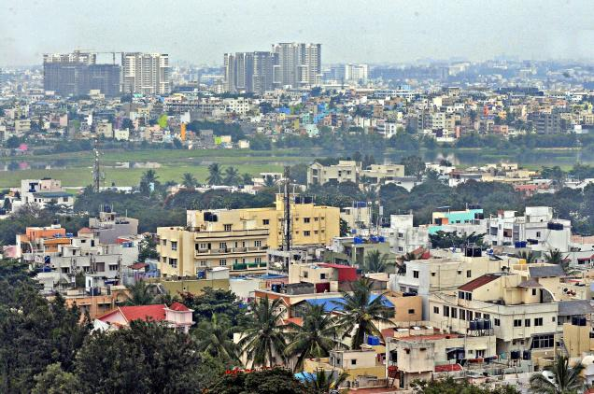
The Bangalore Metropolitan Planning Committee will have to prepare a draft development plan for five years, preferably co-terminous with the State’s Five Year Plan. — File Photo: V. Sreenivasa Murthy
TOPICS

government

government departments

public officials

public works & infrastructure

health

civil and public service

Draft Bangalore Metropolitan Planning Committee Rules issued
Twenty years after the Constitution of India mandated setting up of metropolitan planning committees to give more powers to urban local bodies, the State government has issued a draft rule indicating the shape of the panel and its responsibilities.
The issuance of draft Bangalore Metropolitan Planning Committee (BMPC) Rules, 2013 on November 7 was not voluntary. The government was only implementing an interim order of the Karnataka High Court, which in February this year restrained the State from granting permission for change of land use till the BMPC is constituted. The court said the government cannot permit changes in the master plan in the absence of an MPC.
After Section 243ZE was introduced in the Constitution through the 74th Amendment Act in 1993, the State government had in 1994 inserted Sections 503 A and B in the Karnataka Municipal Corporations Act, 1976 making provisions for creation of MPC and prepare development plans.

Composition of BMPC
The BMPC will comprise 30 members. It will include the Chief Minister, the Minister for Urban Development and the Principal Secretary of the department, the chairperson and commissioner of Bangalore Development Authority, chairpersons of Bescom and BWSSB, commissioner of Bangalore Metropolitan Region Development Authority (BMRDA) and a representative of the Union government.
Eighteen members would be elected by and from amongst elected representatives of urban local bodies, including Bruhat Bangalore Mahanagara Palike (BBMP). Two members will be elected from amongst presidents and vice-presidents of zilla, taluk and grama panchayats within the metropolitan area. MLAs and MLCs whose constituencies fall within the metropolitan area will be permanent invitees. Two persons from among eminent economists and experts in town planning would be special invitees. The chairperson would be selected from among the members.
As per the rule, the BMPC will have to prepare a draft development plan for a period of five years, preferably co-terminous with the State’s Five Year Plan, and bring it to the notice of the public through newspapers; invite objections, hear objections and suggestions from the public before submitting the draft plan to the BMRDA’s Director of Town Planning and the State government, which may approve the draft plan with or without modification. The rules also permit the BMPC to modify the approved plan at any time, but only after inviting objections and suggestions from the public.
The BMPC will review fiscal and physical performance of previous annual plans; state policies, strategies, priorities and major projects for 25 years, advise local bodies and sort out differences among them. It would also serve as a nodal agency for disbursement of funds to the local planning and development authorities.

Raw deal for BBMP
Neither the mayor nor the BBMP commissioner will be part of the BMPC. The mayor may be one of those to be elected from among representatives of local urban bodies, but is not guaranteed a place.
Kathyayini Chamaraj, executive trustee of Citizens Voluntary Initiative for the City (CIVIC), wondered how the BBMP, which is a key component of the metropolitan area, has no ex-officio representation in the BMPC.
Secondly, she questioned the presence of the chief minister and minister for urban development as the BMPC will submit draft development plans to the government for approval. The presence of the CM and the minister seems inappropriate, she said.
Ms. Chamaraj said the draft rule is not as per the letter and spirit of the 74 amendment of the constitution and requires several changes. She also urged the government to extend the deadline for receiving objections and suggestions.
Keywords: BBMP, Bangalore Metropolitan Planning Committee
More In: Bangalore

http://www.thehindu.com/news/cities/bangalore/govt-takes-baby-steps-towards-planned-development-of-city/article5376657.ece

